Congratulations and welcome to the Harris Health School of Diagnostic Medical Imaging! We are excited to have you join our program and looking forward to an exciting learning journey with you. Please read these instructions entirely before beginning the payment process.
To make a fee payment for the School of Diagnostic Medical Imaging, visit: https://hchdfoundation.org/schoolofdiagnostic/
**Please note, this payment option is only for fees. This site is not to be used for tuition payments**
When you arrive at our payment site, you will use your mouse to click on “Click Here to Pay Student Fees”
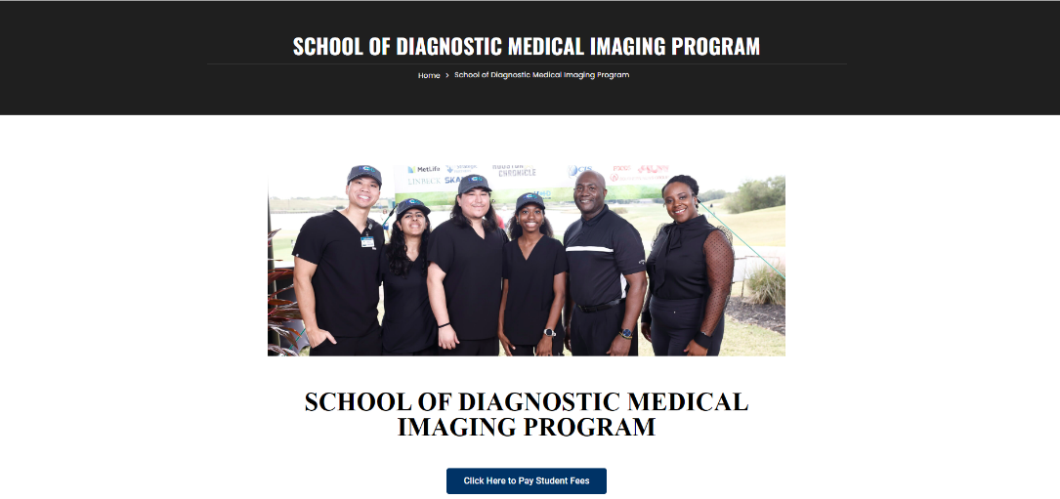

On the next page, you will select the button labeled “Acceptance Fee” of $150 and in the comment box, please include your full name (first name and last name) and the program you are entering.
Ex: Jane Smith – CT Fellowship
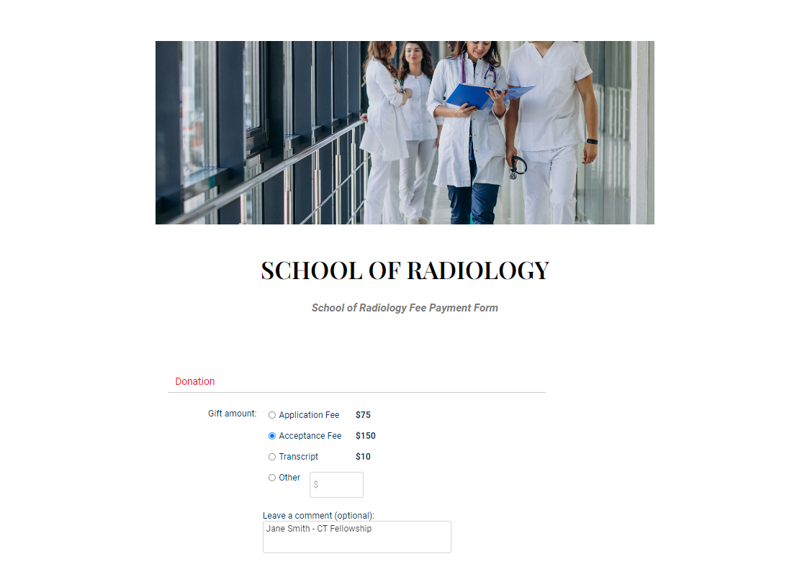

Once you have selected the fee and provided your information, scroll down the page to enter your credit/debit card billing information. You will need the credit/debit card owners name, email, phone number and full billing address.
**Please double check the email address entered, your payment confirmation will be sent there**
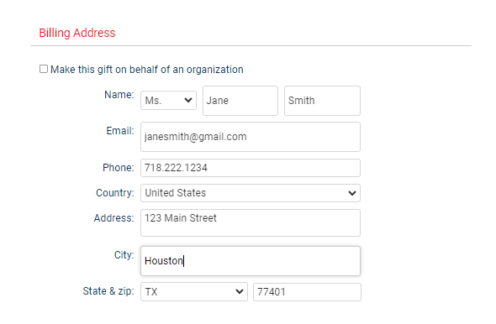

After entering your billing information, scroll down to the next section to include your credit/debit card information. Be sure to double check you have entered the correct card number, expiration date and CSC (also known as CVV).
When all of the information has been entered, click on “Donate” to complete your payment transaction.
You will receive an email confirmation of your payment to the email address provided in the billing section. Please save this confirmation for your records.
