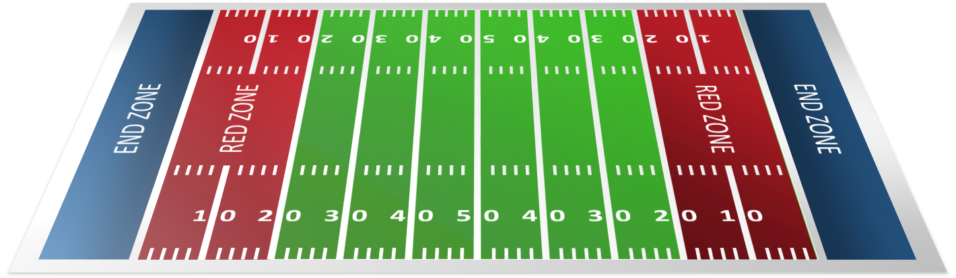

ARE YOU READY FOR SOME

THURSDAY NIGHT FOOTBALL?

RAFFLE TICKETS

Benefiting Harris Health System –

Diagnostic Medical Imaging Programs

Houston Texans -vs- Indianapolis Colts

Thursday, November 21, 2019 @ 7:20pm NRG Stadium

2-Football Tickets & Yellow Lot Parking Pass

SEC: 118 ROW: Y SEATS: 5 & 6 (behind the goal post)

*Come observe the Texans warming up prior to the start of the game!*

1 – Ticket = $5.00 or 5 – Tickets = $20.00

TICKETS SOLD: October 7th – November 5th

Drawing to be held on

Friday, November 8, 2019 @ 12noon - BTGH Auditorium-NPC Building

**TO PURCHASE TICKETS….**

Stop by: HCHD-FOUNDATION 2525 Holly Hall, Suite 292; CALL: 713-566-6409

Online Purchase: hchdfoundation.org/texanticketraffle

SCHOOL OFFICE- 9250 Kirby, Suite 1800; CALL: 713-634-1550

Or Any

Diagnostic Medical Imaging Program Student(s)

GOOD LUCK!!!

(The tickets for this raffle are being donated and this event will support and benefit the Diagnostic Medical Imaging Programs students to include Radiography, Sonography and CT & MRI Fellows as they continue their winning quest in the

Annual State Competition for Texas Society of Radiologic Technologist (TSRT)

