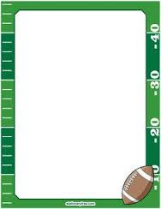
RAFFLE TICKETS
Benefiting Harris Health System
School of Diagnostic Medical Imaging
Houston Texans 
-vs-
Arizona Cardinals
November 19th
@ 12noon
NRG Stadium
2-Football Tickets & Yellow Lot Parking Pass
SEC: 118
ROW: Y
SEATS: 5 & 6
(behind the goal post)
You can observe the Texans warming up prior to the start of the game.

1 – Ticket = $5.00
5 – Tickets = $20.00

Drawing to be held on
Friday, November 10, 2017 at 12Noon
9250 Kirby, Suite 1800

How to win?

To purchase tickets, stop by the Offices listed at:
HCHD-FOUNDATION - 2525 Holly Hall, Suite 292; CALL: 713-566-6409
or
purchase thru
School of Diagnostic Medical Imaging Students

The Raffle will support
Harris Health System
Diagnostic Medical Imaging Students
(Radiography, Sonography, CT & MRI Fellows)
as they continue their winning quest in the
Annual State Competition for Texas State Radiologic Technologist.

(These tickets are being donated and this event will benefit the
Diagnostic Medical School of Imaging students to include
Radiography, Sonography, CT & MRI Fellows)

GOOD LUCK!!!

